|  |  |
| --- | --- |
|  | **AIR UNIVERSITY** |
| **DEPARTMENT OF ELECTRICAL AND COMPUTER ENGINEERING** |
| **EXPERIMENT NO 8** |



**Lab Title:**

**Student Name: Reg. No:**

**Objective:**

**LAB ASSESSMENT:**

|  |  |  |  |  |  |
| --- | --- | --- | --- | --- | --- |
| **Attributes** | **Excellent (5)** | **Good (4)** | **Average (3)** | **Satisfactory (2)** | **Unsatisfactory (1)** |
| **Ability to Conduct Experiment** |  |  |  |  |  |
| **Ability to assimilate the**  **results** |  |  |  |  |  |
| **Effective use of lab**  **equipment and follows the lab safety rules** |  |  |  |  |  |

Total Marks: Obtained Marks:

**LAB REPORT ASSESSMENT:**

|  |  |  |  |  |  |
| --- | --- | --- | --- | --- | --- |
| **Attributes** | **Excellent**  **(5)** | **Good**  **(4)** | **Average**  **(3)** | **Satisfactory**  **(2)** | **Unsatisfactory**  **(1)** |
| **Data presentation** |  |  |  |  |  |
| **Experimental results** |  |  |  |  |  |
| **Conclusion** |  |  |  |  |  |

Total Marks: Obtained Marks:

Date: Signature:

# EXPERIMENT 08



**Decoder and Encoder**

# Objectives:

To have a basic understanding of decoders and encoders.

To experimentally verify the operation of decoder and encoder.

# Equipment required:

ICs as required

Digital Electronics Trainer

**Background Knowledge:**

**Decoder:**

In digital electronics, a decoder can take the form of a multiple-input, multiple-output logic circuit that converts coded inputs into coded outputs, where the input and output codes are different e.g. n-to-2n , binary-coded decimal decoders. Decoding is necessary in applications such as data multiplexing, 7 segment display and memory address decoding.

**Encoder:**

An encoder is a device, circuit, transducer, software program, algorithm or person that converts information from one format or code to another.

**Task 1:**

**Use basic gates to implement and design a 2 to 4 line decoder. Steps:**

1. Complete the truth table given below for a decoder
2. Write the logic equations formed.
3. Patch the equations on the trainer (do not UN patch the circuit, as it will be used later)

|  |  |  |  |  |  |
| --- | --- | --- | --- | --- | --- |
| **Truth Table** | | | | | |
| **A** | **B** | **D0** | **D1** | **D2** | **D3** |
| 0 | 0 |  |  |  |  |
| 0 | 1 |  |  |  |  |
| 1 | 0 |  |  |  |  |
| 1 | 1 |  |  |  |  |

**Equations:**



**Simulation Results:**

**Task 2:**



**Use basic gates to implement and design a 4 to 2 line encoder. Steps:**

1. Complete the truth table given below for an encoder.
2. Write the logic equations formed.
3. Patch the equations on the trainer accordingly.

|  |  |  |  |  |  |
| --- | --- | --- | --- | --- | --- |
| **Truth Table** | | | | | |
| **D0** | **D1** | **D2** | **D3** | **A** | **B** |
| 1 | 0 | 0 | 0 |  |  |
| 0 | 1 | 0 | 0 |  |  |
| 0 | 0 | 1 | 0 |  |  |
| 0 | 0 | 0 | 1 |  |  |

**Equations:**



**Task 3:**

**Consider the following diagram, which means if we connect a decoder and an encoder (of same order) in series we should get back our input.**

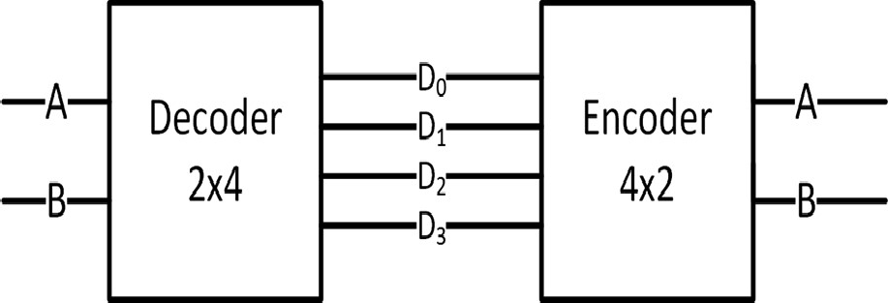

**Connect the above designed decoder and encoder in series and verify the results. Truth Table:**

|  |  |  |  |  |  |  |  |
| --- | --- | --- | --- | --- | --- | --- | --- |
| **A** | **B** | **D0** | **D1** | **D2** | **D3** | **A** | **B** |
| 0 | 0 |  |  |  |  |  |  |
| 0 | 1 |  |  |  |  |  |  |
| 1 | 0 |  |  |  |  |  |  |
| 1 | 1 |  |  |  |  |  |  |



# Conclusion: